Chapter 7 Questions Continued

Swapnil Kamate

31. Write a query to display the employee number, last name, first name, salary “from” date, salary end date, and salary amount for employees 83731, 83745, and 84039. Sort the output by employee number and salary “from” date.

Answer:

SELECT e.emp_num,e.emp_lname,e.emp_fname,s.sal_from,s.sal_end,s.sal_amount

FROM lgemployee as e

join lgsalary_history as s

on e.emp_num = s.emp_num

WHERE e.emp_num in (83731,83745,84039)

ORDER BY e.emp_num , s.sal_from ;

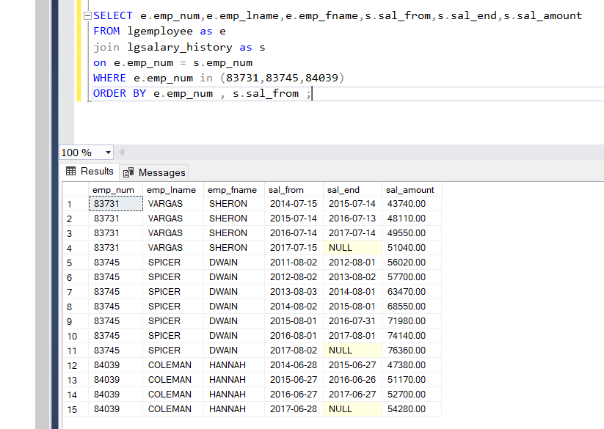

32. Write a query to display the first name, last name, street, city, state, and zip code of any customers who purchased a foresters best brand top coat between July 15, 2015 and July 31, 2015. If a customer purchased more than one such product, display the customers information only once in the output. Sort the output by state, last name, and then the first name.

Answer:

NOTE: Used Data as per the instruction through canvas

SELECT DISTINCT cust_fname,cust_lname,cust_street,cust_city,cust_state,cust_zip

FROM lgcustomer AS c

JOIN lginvoice AS i

ON c.cust_code = i.cust_code

WHERE i.inv_date BETWEEN '2017-7-15' AND '2017-7-31'

ORDER BY cust_state,cust_lname,cust_fname;

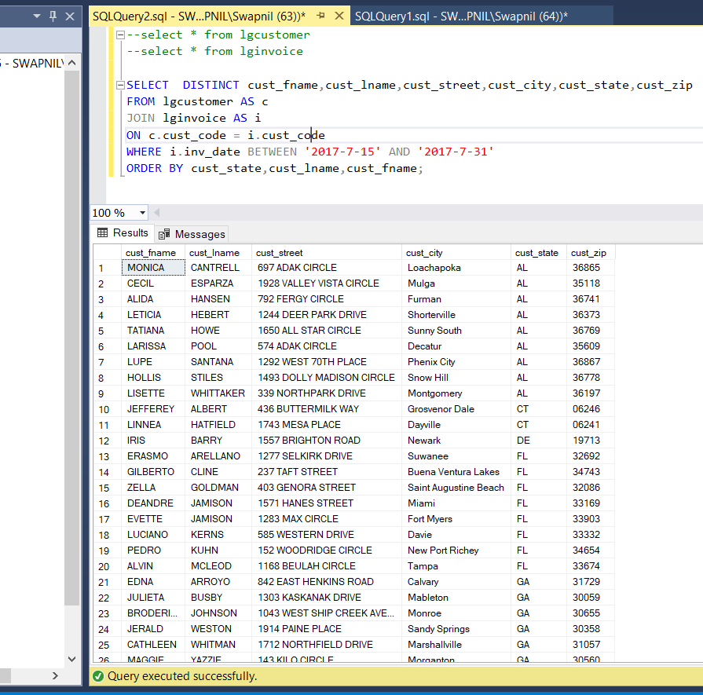

33. Write a query to display the employee number, last name, email, title and department name of each employee whose job title ends with the word associate. Sort the output by department name and employee title.

Answer:

SELECT e.emp_num,e.emp_lname,e.emp_email,e.emp_title,d.dept_name

FROM lgemployee as e

join lgdepartment as d

ON e.dept_num = d.dept_num

WHERE e.emp_title LIKE '%ASSOCIATE'

ORDER BY d.dept_name,e.emp_title ;

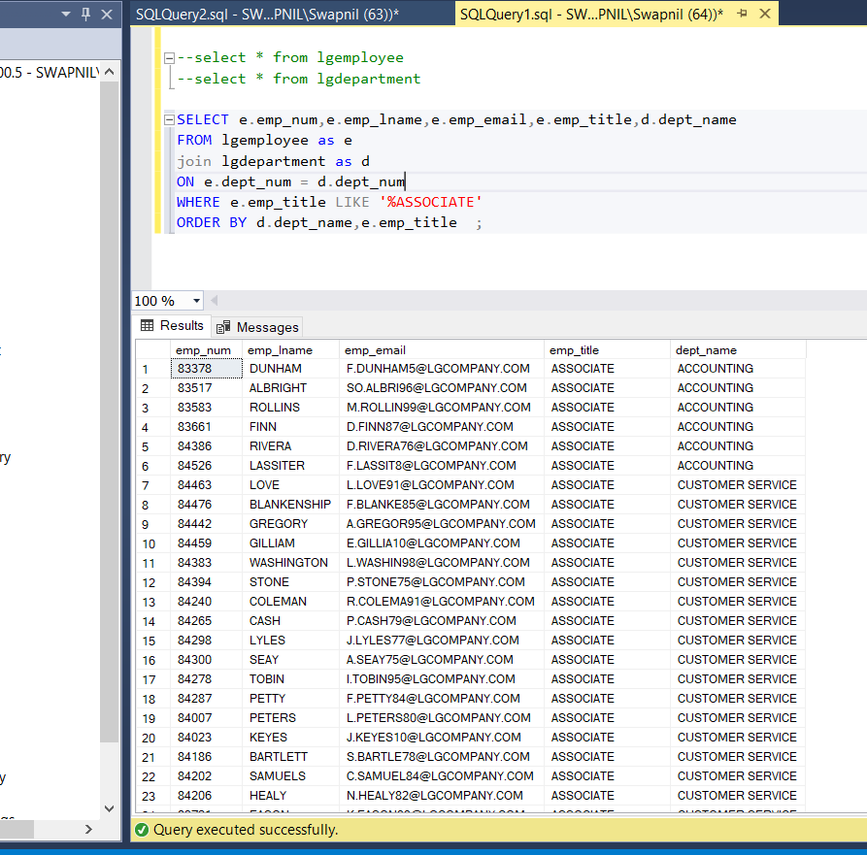

34. Write a query to display a brand name and the number of products of that brand that are in the database. Sort the output by brand name.

Answer:

SELECT b.brand_name , COUNT(p.brand_id) AS NUMPRODUCTS

FROM lgbrand AS b

join lgproduct AS p

ON b.brand_id = p.brand_id

GROUP BY b.brand_name

ORDER BY b.brand_name

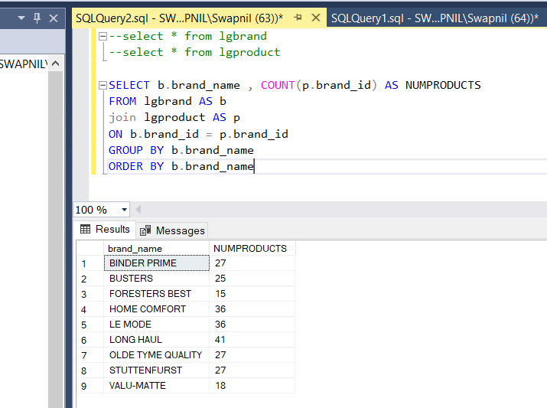

35. Write a query to display the number of products in each category that have a water base, sorted by category.

Answer:

SELECT prod_category, COUNT(prod_category) AS NUMPRODUCT

FROM lgproduct

where prod_base = 'Water'

GROUP BY prod_category

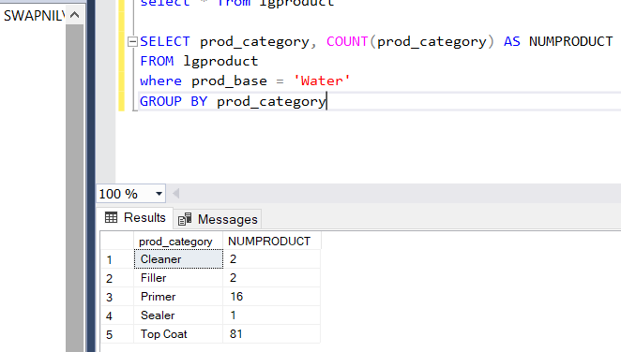

36. Write a query to display the number of products within each base and type combination, sorted by base and then by type.

Answer:

SELECT prod_base,prod_type, COUNT(prod_type) AS NUMPRODUCT

FROM lgproduct

GROUP BY prod_base,prod_type

ORDER BY prod_base,prod_type

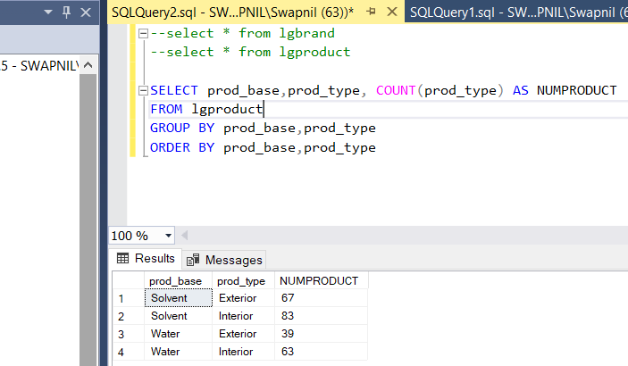

37. Write a query to display the total inventory- that is the sum of all products on hand for each brand ID. Sort the output by brand ID in descending order.

Answer:

SELECT b.brand_id , SUM(p.prod_qoh) AS TOTALINVENTORY

FROM lgbrand AS b

JOIN lgproduct AS p

ON b.brand_id = p.brand_id

GROUP BY b.brand_id

ORDER BY b.brand_id desc

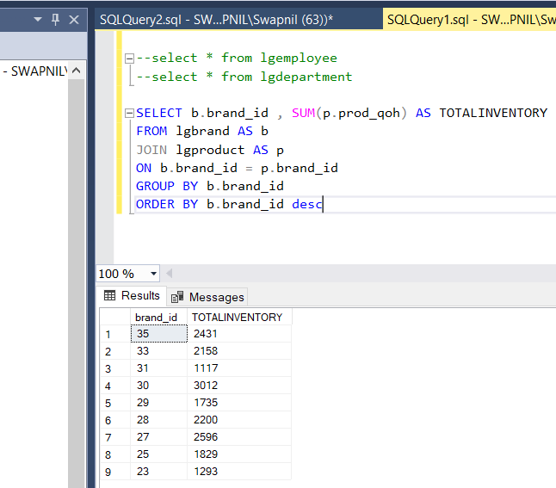

38. Write a query to display the brand id, brand name, and average price of products of each brand. Sort the output by brand name. Results are shown with the average price rounded to two decimal places.

Answer:

SELECT b.brand_id,b.brand_name, ROUND(AVG(p.prod_price),2) AS AVGPRICE

FROM lgbrand AS b

join lgproduct AS p

ON b.brand_id = p.brand_id

GROUP BY b.brand_id,b.brand_name

ORDER BY b.brand_name

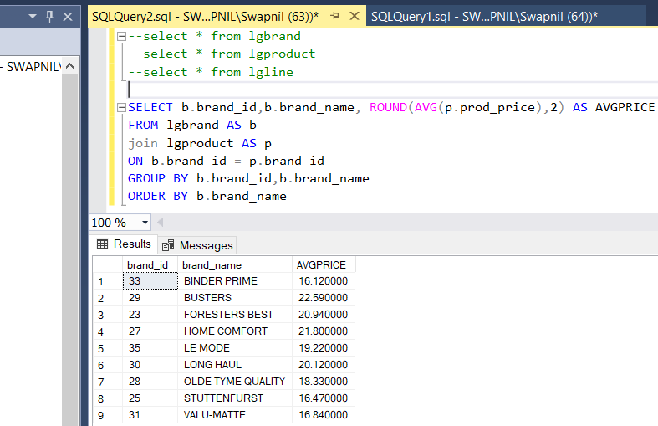

39. Write a query to display the department number and most recent employee hire date for each department. Sort the results by department number.

Answer:

SELECT E.DEPT_NUM, MAX(E.EMP_HIREDATE) AS MOSTRECENT

FROM LGEMPLOYEE E

GROUP BY E.DEPT_NUM

ORDER BY E.DEPT_NUM

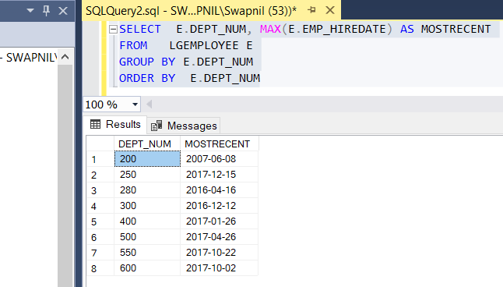

40. Write a query to display the employee number, first name, last name, and largest salary amount for each employee in department 200. Sort the output by largest salary in descending order.

Answer:

SELECT E.EMP_NUM, E.EMP_FNAME, E.EMP_LNAME, MAX(S.SAL_AMOUNT) AS 'LARGESTSALARY'

FROM LGEMPLOYEE E

INNER JOIN LGSALARY_HISTORY S

ON E.EMP_NUM = S.EMP_NUM

WHERE E.DEPT_NUM = 200

GROUP BY E.EMP_NUM, E.EMP_FNAME, E.EMP_LNAME, E.DEPT_NUM

ORDER BY LARGESTSALARY DESC

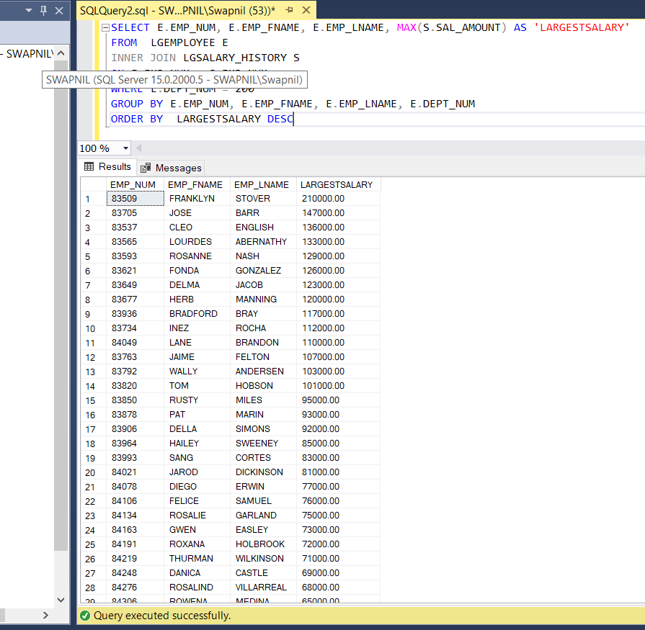

41. Write a query to display the customer code, first name, last name, and sum of all invoice totals for customers with cumulative totals greater than $1500. Sort the output by the sum of invoice totals in descending order.

Answer:

SELECT l.cust_code,l.cust_fname,l.cust_lname,SUM(i.inv_total) AS TOTALINVOICES

FROM lgcustomer AS l

join lginvoice AS i

ON l.cust_code = i.cust_code

GROUP BY l.cust_code,l.cust_fname,l.cust_lname

HAVING sum(i.inv_total) > 1500

ORDER BY sum(i.inv_total) DESC

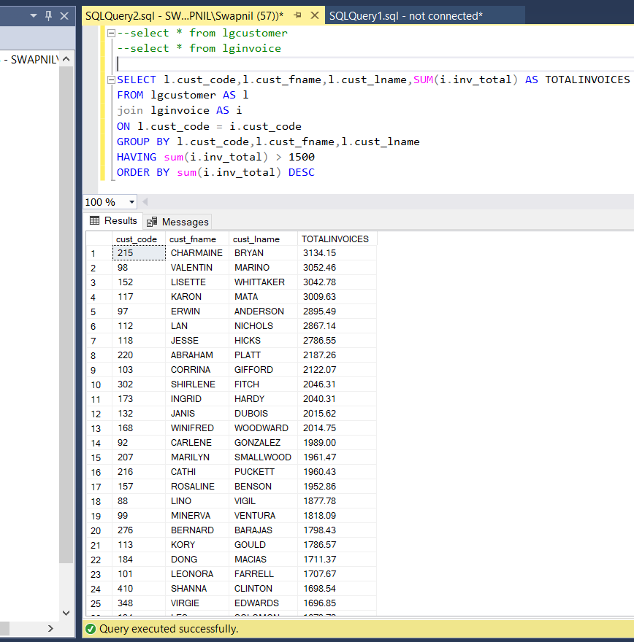

42. Write a query to display the department number, department name, department phone number, employee number, and last name of each department manager. Sort the output by department name.

Answer:

SELECT d.dept_num,d.dept_name,d.dept_phone,d.emp_num,e.emp_lname

from lgdepartment as d

join lgemployee as e

on d.emp_num = e.emp_num

order by d.dept_name

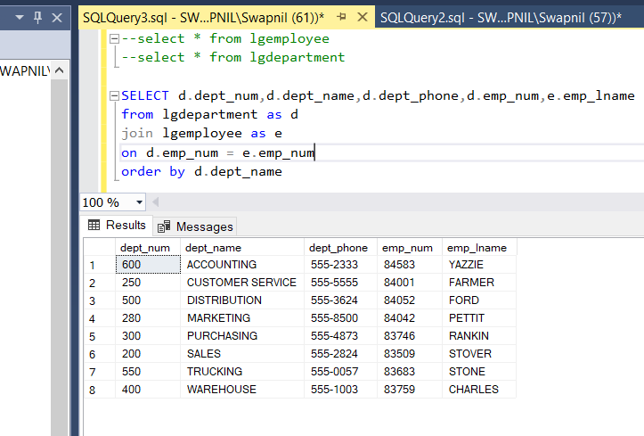

43. Write a query to display the vendor id, vendor name, brand name, and number of products each brand supplied by each vendor. Sort the output by vendor name and then by brand name.

Answer:

SELECT v.vend_id,v.vend_name,b.brand_name,COUNT(p.prod_sku) AS NUMPRODUCTS

FROM lgproduct AS p

join lgsupplies AS s

ON p.prod_sku = s.prod_sku

join lgbrand AS b

ON p.brand_id = b.brand_id

join lgvendor AS v

ON s.vend_id = v.vend_id

GROUP BY v.vend_id,v.vend_name,b.brand_name

ORDER BY v.vend_name,b.brand_name

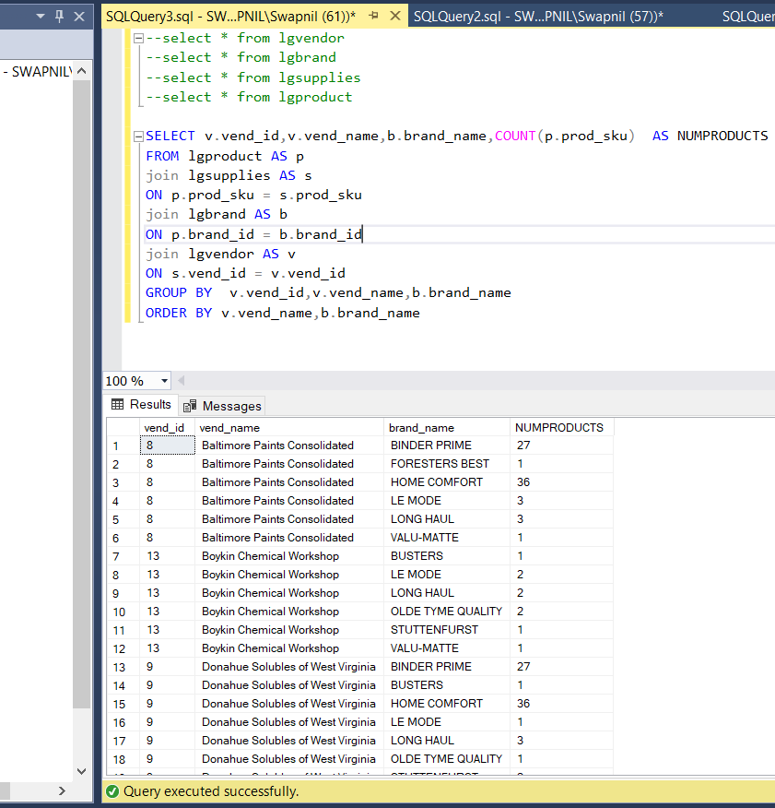

44. Write a query to display the employee number, last name, first name, and sum of invoice totals for all the employees who completed an invoice. Sort the output by employee last name and then first name.

Answer:

SELECT e.emp_num,e.emp_lname,e.emp_fname,SUM(i.inv_total) AS TOTALINVOICE

FROM lgemployee AS e

join lginvoice AS i

ON e.emp_num = i.employee_id

GROUP BY e.emp_num,e.emp_lname,e.emp_fname

ORDER BY e.emp_lname,e.emp_fname

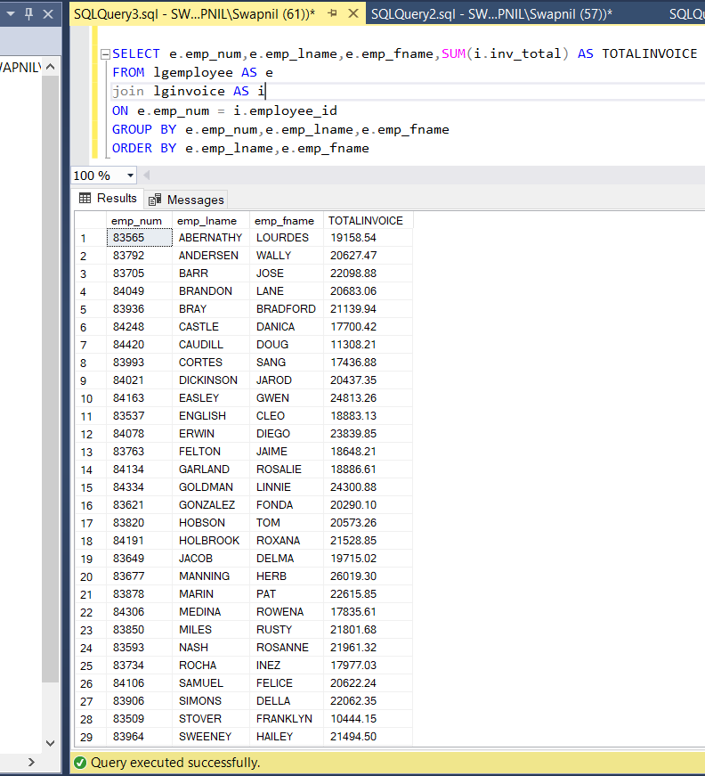

45. Write a query to display the largest average product price of any brand.

Answer:

SELECT TOP 1 AVG(p.prod_price) AS [Largest Average]

FROM lgproduct AS p

join lgbrand AS b

ON p.brand_id = b.brand_id

GROUP BY b.brand_id

ORDER BY avg(p.prod_price) DESC

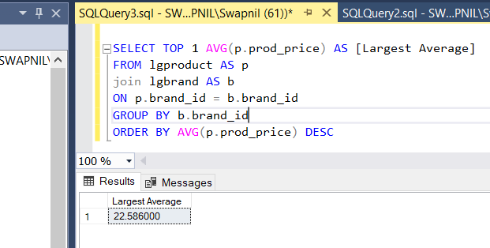

46. Write a query to display the brand id, brand name, brand type, and average price of products for the brand that has the largest average product price.

Answer:

SELECT TOP 1 AVG(p.prod_price) AS [Largest Average],b.brand_id,b.brand_name,b.brand_type

FROM lgproduct AS p

join lgbrand AS b

ON p.brand_id = b.brand_id

GROUP BY b.brand_id,b.brand_name,b.brand_type

ORDER BY AVG(p.prod_price) DESC

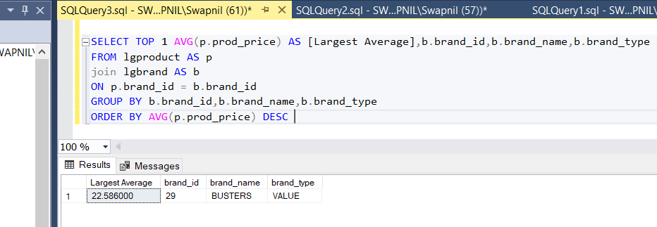

47. Write a query to display the manager name, department name, department phone number, employee name, customer name, invoice date, and invoice total for the department manager of the employee who made a sale to a customer whose last name Hagan on May 18, 2015.

Answer:

SELECT M.EMP_FNAME, M.EMP_LNAME, D.DEPT_NAME, D.DEPT_PHONE, E.EMP_FNAME, E.EMP_LNAME, C.CUST_FNAME,C.CUST_LNAME,I.INV_DATE, I.INV_TOTAL

FROM LGDEPARTMENT D, LGEMPLOYEE M, LGEMPLOYEE E, LGCUSTOMER C, LGINVOICE I

WHERE D.EMP_NUM = M.EMP_NUM

AND E.EMP_NUM = I.EMPLOYEE_ID

AND D.DEPT_NUM = E.DEPT_NUM

AND I.CUST_CODE = C.CUST_CODE

AND C.CUST_LNAME = 'HAGAN'

AND I.INV_DATE = '2017-05-18'

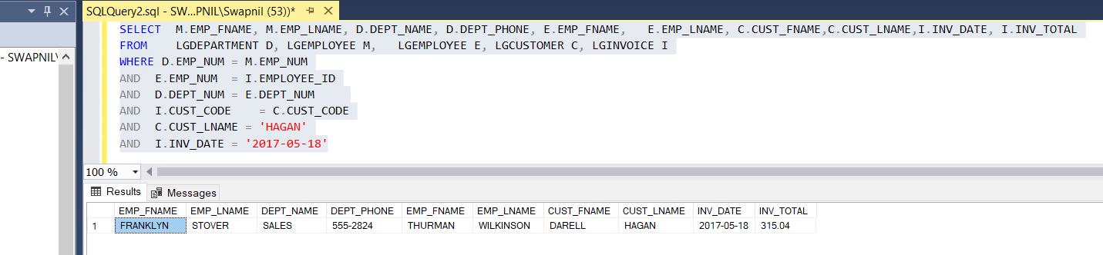

48. Write a query to display the current salary for each employee in department 300. Assume that only current employees are kept in the system, and therefore the most current salary for each employee is the entry in the salary history with a null and end date. Sort the output in descending order by salary amount.

Answer:

select e.emp_num,e.emp_lname,e.emp_fname,s.sal_amount

from lgemployee as e

join lgsalary_history as s

on e.emp_num = s.emp_num

join lgdepartment as d

on e.dept_num = d.dept_num

where e.dept_num = 300 and s.sal_end is null

order by s.sal_amount desc

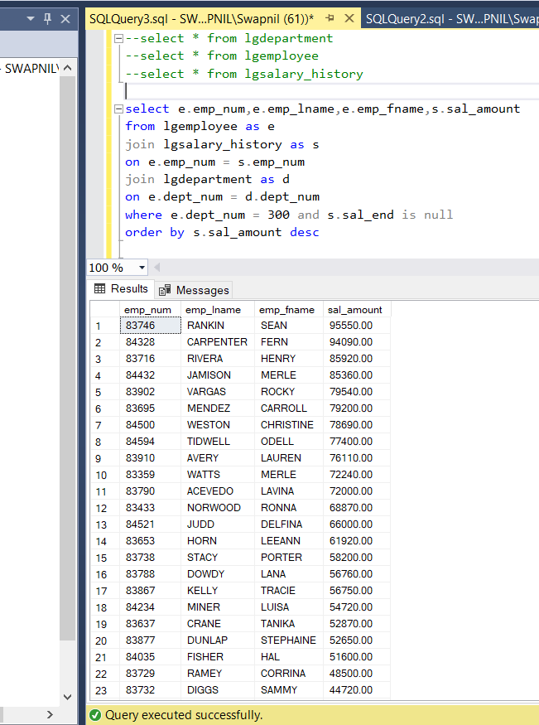

49. Write a query to display the starting salary for each employee. The starting salary would be the entry in the salary history with the oldest salary start date for each employee. Sort the output by employee number.

Answer:

select e.emp_num,e.emp_lname,e.emp_fname,min(s.sal_amount) AS Sal_Amount

from lgemployee as e

join lgsalary_history as s

on e.emp_num = s.emp_num

join lgdepartment as d

on e.dept_num = d.dept_num

group by e.emp_num,e.emp_lname,e.emp_fname

order by e.emp_num

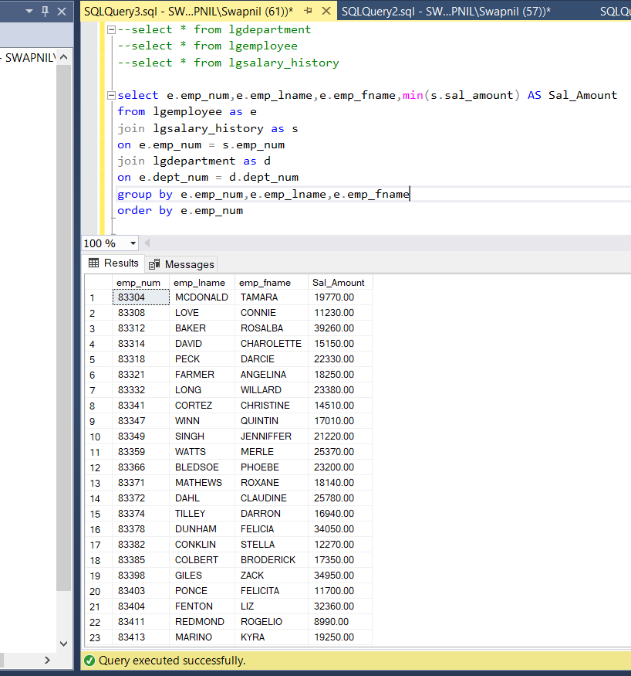

50. Write a query to display the invoice number, line numbers, product sku’s, product descriptions, and brand id for sales of sealer and top coat products of the same brand on the same invoice. Sort the results by invoice number in ascending order, first line number in ascending order, and then by second line number in descending order.

Answer:

SELECT C1.INV_NUM AS INV_NUM, C1.LINE_NUM AS L1_LINE_NUM, C1.PROD_SKU AS

P1_PROD_SKU, C1.PROD_DESCRIPT AS P1_PRODUCT_DESCP, C2.LINE_NUM AS

L2_LINE_NUM, C2.PROD_SKU AS P1_PROD_SKU, C2.PROD_DESCRIPT AS

P2_PRODUCT_DESCP, C1.BRAND_ID AS BRAND_ID

FROM ( SELECT L.INV_NUM, L.LINE_NUM, P.PROD_SKU, P.PROD_DESCRIPT, P.BRAND_ID,

P.PROD_CATEGORY

FROM LGLINE L, LGPRODUCT P

WHERE L.PROD_SKU = P.PROD_SKU AND P.PROD_CATEGORY = 'SEALER') C1,

( SELECT L2.LINE_NUM, P2.PROD_SKU, P2.PROD_DESCRIPT, P2.BRAND_ID,

L2.INV_NUM, P2.PROD_CATEGORY

FROM LGLINE L2, LGPRODUCT P2

WHERE L2.PROD_SKU = P2.PROD_SKU AND P2.PROD_CATEGORY = 'TOP COAT') C2

WHERE C1.INV_NUM = C2.INV_NUM

AND C1.BRAND_ID = C2.BRAND_ID

ORDER BY C1.INV_NUM, C1.LINE_NUM,C2.LINE_NUM DESC;

